**Group *3***: - Report *4*

**CSE523 Machine Learning**

**Heart Attack Prediction**

|  |  |
| --- | --- |
| **Group Members** | **Roll No** |
| **Shivam Thakker** | **AU1940193** |
| **Devarsh Sheth** | **AU1940189** |
| **Pranav Gandhi** | **AU1940313** |
| **Meet Jhaveri** | **AU1940284** |

* After doing correlation analysis, dropping uncorrelated features and outlier detection, the next step was to carry out Standardization.
* Here Standardization is use to bring down all the attributes to mean 0 and variance 1. So, the main aim of Standardization is to bring down all the features to a common scale without distorting the differences in the range of the values.
* Here we have used an inbuilt function which is StandardScaler which is offered by Sklearn library. It is used to standardize the data values into a standard format.

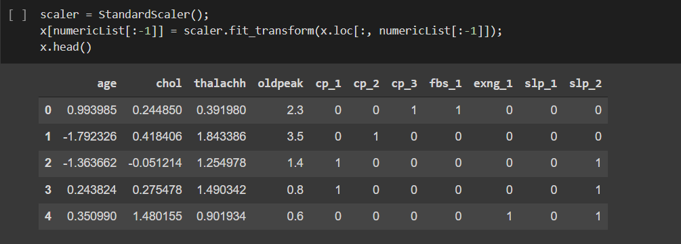

* After this we have divided data into train and test set.

KNN model:

* Here we have used KNN model to predict the heart attack.
* We have used an inbuilt function KNeighborsClassifier provided by Sklearn Library. After this we first fit the model and then test the model.

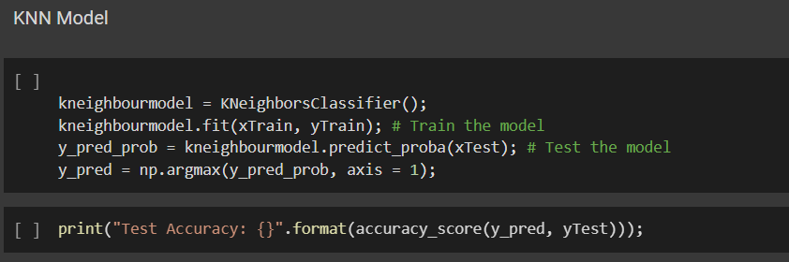

The accuracy which we are getting in this case was 83%.

Thank You